CO2 AT3 DEBUGGING

NAME: Siddhi Srivastava.P
REGISTER NO: 192521454
COURSE NAME: Database Management Systems
COURSE CODE: CSA0503

COURSE OUTCOME COVERED
CO2: Apply the relational model, relational algebra, SQL query structures, and views to solve database querying and data manipulation problems. (BL3, BL6)
Activity Tool : Debugging &amp; Optimisation Task (Low)

Assessment Tool Weightage: 30%
- Identify and fix the error in the given SQL query that uses incorrect JOIN syntax and returns duplicate results.

Incorrect query:
SELECT E.Emp_ID, E.Emp_Name, D.DeptName FROM Employee E, Department D;

Error
  - No JOIN condition.
  - Produces Cartesian Product (duplicate records).

Correct query:
SELECT
E.Emp_ID, E.Emp_Name, D.DeptName
FROM Employee E
INNER JOIN Department D ON E.DeptID = D.DeptID;

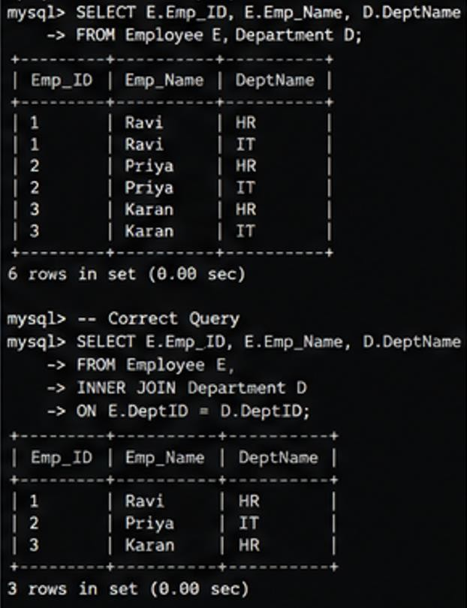

- The following sub-query returns incorrect results due to a missing correlation. Debug and rewrite it correctly.

Incorrect query:
SELECT Emp_Name FROM Employee E WHERE Salary >
(SELECT AVG(Salary) FROM Employee);

Error
  - Finds employees above company average.
  - Question requires department average.

Correct query:
SELECT Emp_Name FROM Employee E WHERE Salary >
(SELECT AVG(Salary) FROM Employee

WHERE DeptID = E.DeptID);
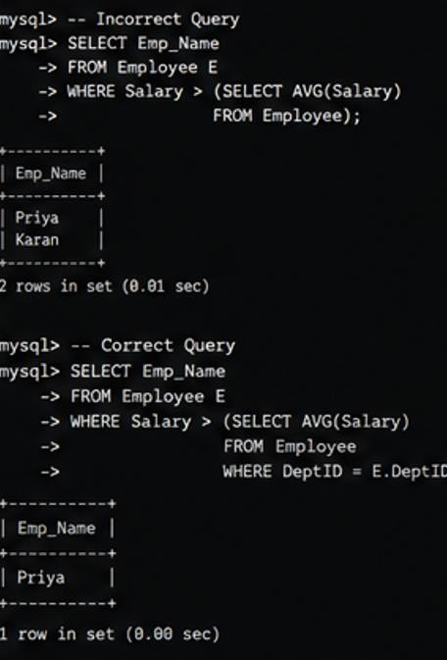

- A given SQL view definition causes errors when queried. Identify the issue and rewrite a correct and optimized view.

Incorrect query:
CREATE VIEW DeptSalaryView AS SELECT DeptName,
AVG(Salary) FROM Employee; Error
  - DeptName does not exist in Employee table.
  - Missing JOIN.
  - Missing GROUP BY

Correct query:
CREATE VIEW DeptSalaryView AS

SELECT
D.DeptName,
COUNT(E.Emp_ID) AS TotalEmployees, AVG(E.Salary) AS AverageSalary
FROM Department D JOIN Employee E
ON D.DeptID=E.DeptID GROUP BY D.DeptName;
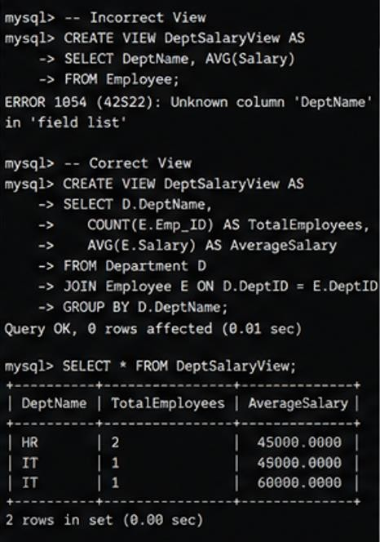

- Debug the given relational algebra expression that produces incorrect output for a natural join operation.

Incorrect query:
Employee × Department

Error
Uses Cartesian Product instead of Natural Join.

Correct query:
Employee ⋈ Department
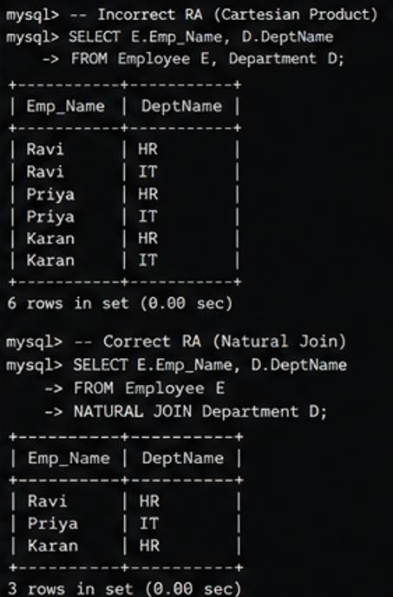

- The SQL query below violates referential integrity. Identify the violation and modify the statements to enforce proper constraints.
Incorrect query: INSERT INTO Employee VALUES (101,'Ravi',50000,'D10');

Error
Department D10 does not exist.

Correct query:
INSERT INTO Department VALUES

('D10','Research'); INSERT INTO Employee VALUES (101,'Ravi',50000,'D10');
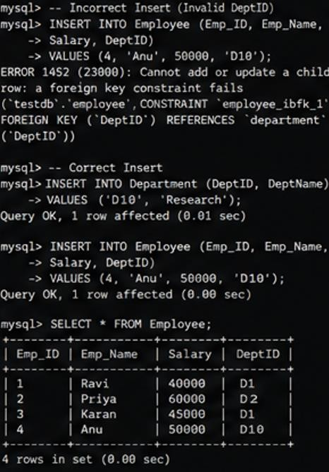

- Given an inefficient SQL query with nested loops, rewrite it using JOIN to optimize performance.
Incorrect query: SELECT Emp_Name FROM Employee WHERE DeptID IN (
SELECT DeptID
FROM Department WHERE DeptName='IT'

);

Error
Uses unnecessary nested query.

Correct query:
SELECT E.Emp_Name FROM Employee E
INNER JOIN Department D ON E.DeptID=D.DeptID WHERE D.DeptName='IT';
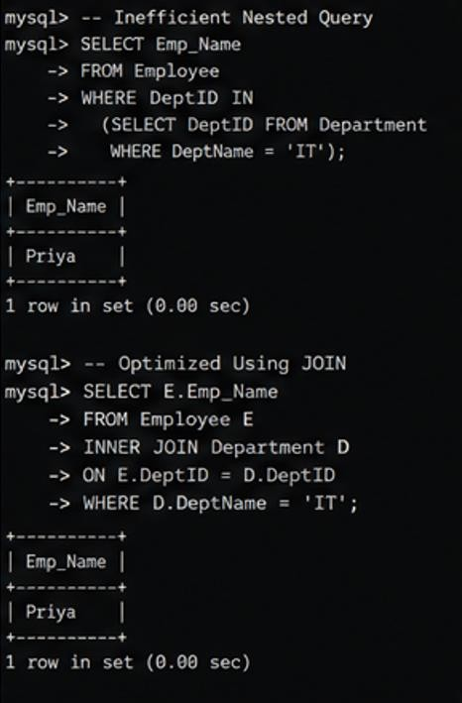

- The GROUP BY query below produces wrong aggregation results.Debug the query and explain the error.

Incorrect query:
SELECT

Category, Product_Name, SUM(Sales) FROM Sales
GROUP BY Category;

Error
Product_Name is not grouped or aggregated.

Correct query:
SELECT
Category,
SUM(Sales) AS TotalSales FROM Sales
GROUP BY Category;
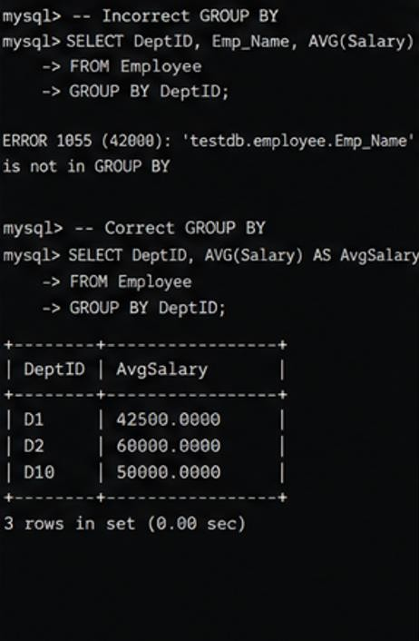

- Identify and fix the logical error in a given SQL UPDATE statement that unintentionally modifies all rows in the table.

Incorrect query:
UPDATE Employee
SET Salary=Salary+5000;

Error
Updates every employee. Correct query: UPDATE Employee
SET Salary=Salary+5000 WHERE DeptID='D3';
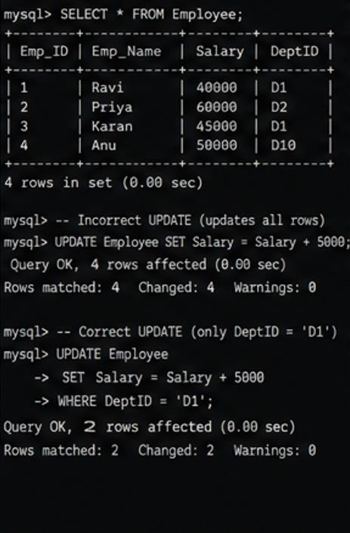

- Optimize the given multi-table SQL query by restructuring sub-queries into JOINs and using appropriate indexes.

Incorrect query:
SELECT CustomerName FROM Customer WHERE CustomerID IN
(SELECT CustomerID FROM Orders WHERE ProductID IN
(SELECT ProductID FROM Product WHERE Price>5000));

Error
Multiple nested subqueries.

Correct query:
SELECT DISTINCT
C.CustomerName FROM Customer C INNER JOIN Orders O
ON C.CustomerID=O.CustomerID INNER JOIN Product P
ON O.ProductID=P.ProductID WHERE P.Price>5000;

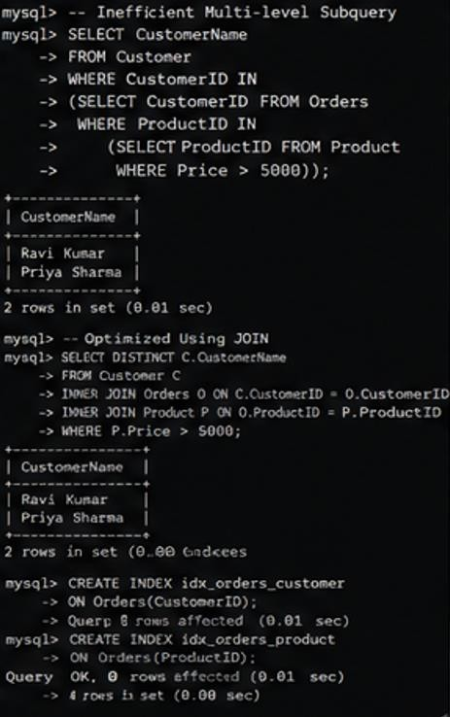

- Debug a given relational calculus expression that returns an empty result set due to incorrect quantifier usage.

Incorrect query:
{E.Name | ∀D (Employee(E) ∧ Department(D) ∧ E.DeptID=D.DeptID)}

Error
Uses ∀ (For All) incorrectly, resulting in an empty result.

Correct query:
{E.Emp_Name |Employee(E)∧∃D(Department(D)∧E.DeptID=D.DeptID)}

